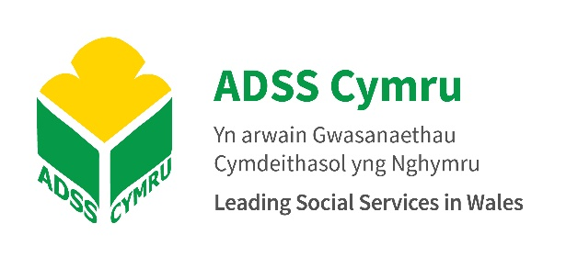

MEDIA RELEASE

Migration Advisory Committee review – a missed opportunity for social care workers in Wales

30 September 2020

FOR IMMEDIATE RELEASE

A review by the UK Government’s Migration Advisory Committee (MAC) of its Shortage Occupation List has recommended that senior care workers be added to the list but failed to support appeals from Welsh social care employers for other occupations in the sector to be included.

The advice from the MAC, which covers all UK home nations, including Wales, means that when new immigration laws come into effect in 2021, social care employers will be unable to recruit internationally to roles that do not meet the minimum skills threshold, or the minimum salary threshold of around £26,500 per annum.

According to research by the Cavendish Coalition – a group of 36 UK health and social care organisations – nearly three quarters of social care occupations across the UK do not meet the RQF3 qualification threshold, nor earn enough to meet the salary threshold.

The MAC review follows the publication of a report this week by the Welsh NHS Confederation that says the new laws would have a negative impact on the social care workforce, which is already experiencing serious shortages and difficulties in recruiting new staff.

In addition, it says the new laws fail to consider significant differences in the social care systems in Wales and England, noting that:

‘By 2022 all domiciliary and residential workers, in both children and adults, must be registered with Social Care Wales, and thus meet specific levels of competence and conduct. This changes the market for these roles fundamentally in Wales: the approach to the SOL must be able to accommodate this difference.’

The Welsh NHS Confederation report also references the concerns raised by social care stakeholders regarding the high minimum salary threshold:

‘Stakeholders said that the salary threshold was particularly concerning as most social care services in Wales operate within a monopsony: the only buyer is the local authority. This limits flexibility in terms of the rates workers are paid and means there is limited scope to raise these.’

The MAC has argued that, ‘migration alone cannot solve the care crisis in the UK more substantially’, however, the classification of social care occupations as ‘low skilled’ along with the MAC’s recommended exclusion of these roles on the SOL is greatly concerning, not only in terms of addressing the immediate shortages of workers in the sector, but because of the depiction of the roles it said should receive greater pay and incentives.
President of the Association of Directors of Social Services (ADSS) Cymru, Nicola Stubbins said:
“The ‘lower skilled’ characterisation of care work is simply not appropriate, or reflective of the challenging nature of the work, particularly in Wales where each member of our workforce is expected to be registered under a regulatory body. Therefore, we feel RQF3 level workers should be included on the Shortage Occupation List.

“As much as we are aware that factors including fair reward, equitable terms and conditions, and professional career pathways must be addressed in order to improve recruitment and retention across the sector, we cannot emphasise enough the importance of continuing to recruit internationally in order to deliver new workers to meet the country’s existing needs.

“It is vital that we create a culture whereby social care is valued for the essential service it delivers to our citizens, and given parity of esteem along with other caring occupations listed on the Shortage Occupation List.

“Meanwhile, the UK Government and Welsh Government must work to make social care an attractive and sustainable profession for domestic workers, one that is adequately funded and appropriately skilled; and we as social care employers will continue to work with our strategic partners to ensure these improvements happen.”

NOTE TO EDITORS:

Contact:

Rachel Pitman
Communications and Engagement Lead, ADSS Cymru Business Unit
rachel.pitman@adss.cymru

- The Association of Directors of Social Services (ADSS) Cymru is the national professional and strategic leadership organisation for social services. We are a membership organisation, representing all 22 local authorities in Wales.
- As the national leadership organisation for social services in Wales, the role of ADSS Cymru is to represent the collective, authoritative voice of Directors of Social Services, Heads of Adult Services, Children’s Services and Business Services, together with professionals who support vulnerable children and adults, their families and communities, on a range of national and regional issues of social care policy, practice and resourcing. It is the only national body that can articulate the view of those professionals who lead our social care services.

